Email to both – Narendra.e16202@cumail.in, ankit.e16400@cumail.in, sangita.e16523@cumail.in, poulabi.e16365@cumail.in, pankita.e16910@cumail.in , shahnawaz.e16871@cumail.in ruby.e16901@cumail.in

INVENTOR DETAIL:

NAME: MOHD SHAN
EMAIL: MOHDSHANCS23@GMAIL.COM
MOBILE NO: 9084296657
SCANNED HAND SIGNATURE:

A) Please enlist the Key concepts and terms/Keywords/Synonyms used in the Invention.
S. No | Keywords for invention have to be search | Synonyms
1 |  | Auto Sync, File Copying, Seamless Data Sharing
  Automatic Data Transfer
2 | USB Data Copier | Flash Drive Copier, USB File Manager, USB Backup Device
3
  Portable Design
  Compact Design, Lightweight Device, Handy Form Factor
4
  Dual-Function Device
  Multi-Purpose Tool, Two-in-One Device, Dual-Use Technology
5
  Keychain USB Copier
  Portable File Copier, Keyring Storage Device, Handy Data Manager
6
  Restricted-Use Areas
  Secured Locations, Controlled Spaces, Limited-Access Zones
7 |  | Automatic USB Sync, USB Synchronization, USB File Backup
  USB Auto Sync

Written Description - Invention Information

1. TITLE OF INVENTION- 15 words max

"AutoSync USB: Seamless Copy & Sync Storage Device!
Auto Sync Pen drive"
Auto Sync USB Copier"
"Auto Sync File Transfer Device"
"Auto Sync Data Copier"
"Portable Auto Sync Device"
• "Smart Auto Sync Device"
• "Auto Sync USB Data Manager"
• "Compact Auto Sync Copier"
• "USB Auto Sync Device"
• "All-in-One Auto Sync File Copier"
• "Auto Sync Storage and Copier Device”

2. BACKGROUND OF THE INVENTION- prior art search, tell what was the problem in past and how your invention overcome it. Compare your invention with closet prior art.

In traditional systems, data transfer from USB drives required manual intervention via computers, making it time-consuming and prone to errors. Most existing devices lack full automation or rely on external software, limiting efficiency.
Our invention offers a fully automatic data-transfer solution with green LEDs during transfer and red LEDs after completion. It features a C-Type port, an ON/OFF button, and a silicone cover for durability. The compact design makes it ideal for restricted-use environments, such as military operations, schools, or intelligence agencies, where larger devices like laptops are not practical.

3. BRIEF SUMMARY OF INVENTION

This invention is a compact, automatic data-copying device designed for seamless transfer. When a USB drive is connected, the green LED turns ON, indicating data transfer. Once the process completes, the red LED turns ON. The device has a C-Type charging port, a power ON/OFF button, and a silicone dust cover to prevent damage.
It serves dual functions—as a data copier and pendrive. The C-Type port supports both charging and data transfer when connected to external devices. Its portable design enables use as a keychain or paperweight, making it ideal for restricted-use areas like military operations or schools.

4. OBJECTIVE OF THE INVENTION

- Automate Data Transfer: Copy data automatically when a USB drive is inserted.
- LED Indicators:
  - Green LED ON: During transfer.
  - Red LED ON: After successful transfer.
- Power ON/OFF Button: Allow the user to manually turn the device ON or OFF.
- Dual Functionality: Acts as both data copier and pendrive.
- C-Type Port: Supports charging and data transfer with laptops or PCs.
- Portable and Durable Design: Works as a keychain or desk accessory.
- Silicone Cover for Protection: Shields components from dust.
- Restricted-Use Suitability: Designed for military and school environments.

5. EXPLAIN PROBLEMS IN PRIOR ART OR EARLIER INVENTION WHICH YOUR PRESENT INVENTION TARGET TO SOLVE POINTWISE.

- Manual Intervention: Traditional data transfer requires manual operation via computers.
- Lack of Automation: Existing devices often require external software to function.
- No Clear Status Feedback: Older solutions lack clear LED-based status indicators.
- No ON/OFF Control: Prior devices lacked an easy way to turn the power ON/OFF.
- Limited Portability: Many devices are too bulky for restricted environments.
- Prone to Damage: Devices without protective covers are vulnerable to dust or damage

5.NOVEL ASPECTS OF THE INVENTION (Point out the new parts used in the invention which make it different from the other existing inventions or prior arts).

- Automatic Data Transfer: Initiates transfer immediately when a USB drive is inserted.
- Real-Time LED Feedback:
  - Green LED ON: During transfer.
  - Red LED ON: After successful transfer.
- Power ON/OFF Button: Allows users to manage power efficiently.
- Silicone Dust Cover: Protects the device from damage.
- Dual-Purpose Design: Acts as both a data copier and a USB storage device.
- C-Type Port: Facilitates charging and data retrieval.
- Portable Design: Compact enough to serve as a keychain or paperweight.
- Student-Friendly and Restricted-Use Suitability: Ideal for environments like schools or military areas.

6. DETAILED DESCRIPTION OF THE INVENTION - Be sure to use as much space as needed, and be as detailed as you can in this section, as anything that is not covered here will not be protected under the patent we may obtain.

***Note: please explain your invention step wise in sequential order and how it works and duly explain all the parts of the device in sequential order with its functionality.

In case of software embedded with device; - explain step wise how the software works with the device and its functionality, with flow chart and diagram. ***
The device features a rectangular housing (3x5x6 cm) with the following components:
- USB Interface: Connects pendrives for automatic data copying.
- LED Indicators:
  - Green LED ON: Transfer in progress.
  - Red LED ON: Transfer complete.
- C-Type Port: Supports both charging and data transfer with external devices.
- Power ON/OFF Button: Located below the C-Type port to manage power efficiently.
- Microcontroller: Manages operations with optimized power consumption.
- Rechargeable Battery: A 500mAh lithium-ion battery powers the device.
- Flash Memory and Controller Chip: Temporarily stores data during transfer.
- Silicone Dust Cover: Shields the USB interface and LED indicators from dust.
How It Works:
- Power ON: Press the ON/OFF button to activate the device.
- Pendrive Detection: The microcontroller detects the connected USB drive.
- Green LED ON: Data transfer begins automatically.
- Red LED ON: Lights up after successful transfer.
- Idle State: The system resets to idle mode once the USB drive is removed.
- PC Connection: When connected via the C-Type port, the device switches to data retrieval mode.
- Power OFF: Press the ON/OFF button to turn off the device.

7. DRAWINGS OR SUPPORT MATERIAL

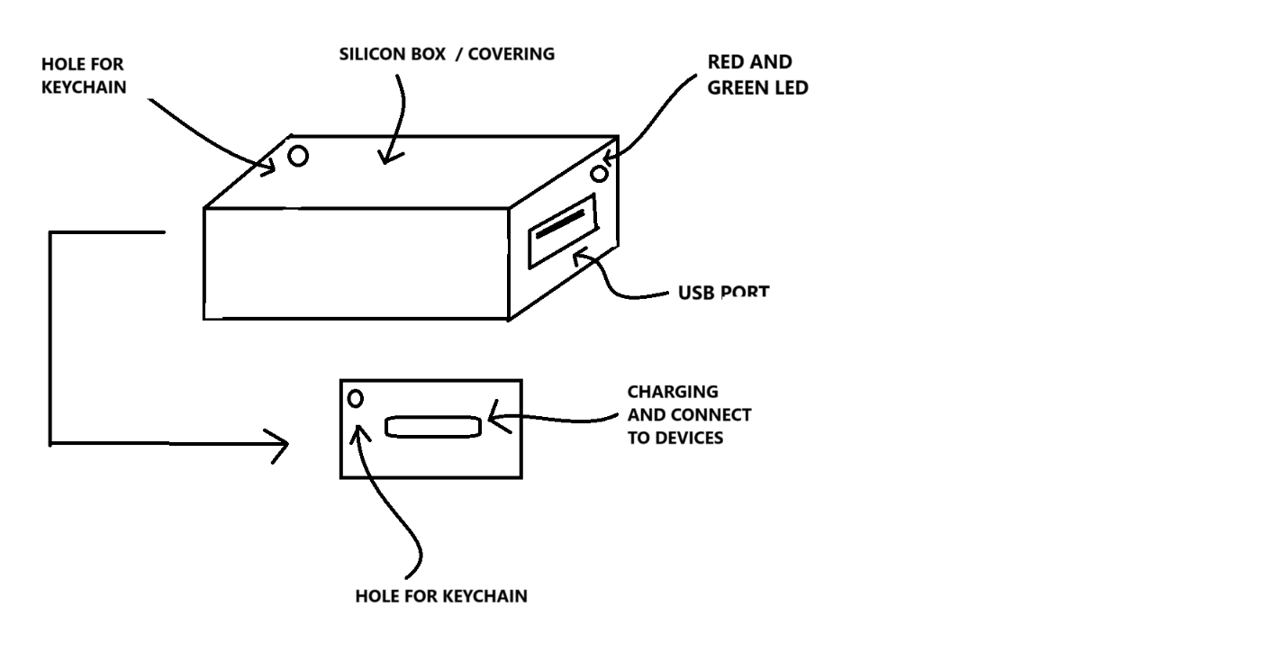

8. SUMMARY OF THE FIGURES / DIAGRAMS / DRAWINGS with the explanation of all parts in the drawing and how it works.

The provided figure illustrates the design and structure of the Automatic Data Copying Device, which resembles a pendrive-like device with additional functionalities.

Figure Description
- Main Body:
  - The device is enclosed in a silicone box/covering, which provides protection from dust and minor impacts.
  - A hole for a keychain is present, allowing it to be carried easily.
- Front Side (USB Interface & LED Indicators):
  - A USB port is positioned on one side, enabling the insertion of external storage devices (e.g., a pendrive).
  - Two LED indicators (Red & Green):
    - Red LED: Indicates that data copying is in progress.
    - Green LED: Indicates that data transfer is complete.
- Back Side (Charging & Connectivity):
  - A charging port is located on the opposite side.
  - This port can also be used to connect the device to a laptop or other external devices, allowing it to function as a pendrive.

9. ABSTRACT (150 words)

The present invention relates to an automatic data copying device designed to facilitate seamless data transfer from a USB storage device (pendrive) without requiring external control. The device is compact, encased in a silicone body for durability, and features an integrated USB port for data input. Upon inserting a pendrive, the device automatically initiates the data copying process, eliminating the need for manual intervention.

A set of LED indicators (red and green) provide real-time status updates—red LED signals active copying, while the green LED confirms completion. The device is also equipped with a charging port, which allows it to function as a standalone data storage device and connect to external systems for data retrieval.

Designed for portability and ease of use, the device includes a keychain hole, making it convenient for everyday carry. This invention is particularly useful for quick and secure data backups, reducing reliance on traditional computers or manual copying methods. The combination of automated operation, portability, and dual functionality makes this device a versatile solution for users requiring fast, efficient, and hassle-free data transfers.

10. BRIEF DETAIL OF PARTS OF THE DEVICE, APPARATUS, PRODUCT IN BULLET POINTS – In case the invention is related to product, device and apparatus.
***Note: Explain the Parts of the Device***
- Start / Power ON
↓
- Initialize Components
↓
- Detect Pendrive Connection?
  - Yes → Validate Device
  - No → Idle Mode
↓
- Data Transfer (Green LED ON)
↓
- Monitor Status:
  - Error? → Flash Green LED
  - No Error → Continue
↓
- Completion (Red LED ON)
↓
- Disconnect or Connect to PC?
  - If Connected → Data Retrieval Mode
  - If Disconnected → Reset to Idle Mode
↓
- Power OFF (Optional)

10. PARTS OF THE DEVICE
- USB Interface
- LED Indicators (Green and Red)
- C-Type Port
- Power ON/OFF Button
- Microcontroller
- Rechargeable Battery
- Flash Memory & Controller Chip
- Silicone Dust Cover

11. BRIEFLY EXPLAIN THE STEPS, FLOW CHART, FUNCTIONALITY OF INVENTION RELARED TO SOFTWARE EMBEDDED WITH MACHINE, DEVICE, APPRATUS.
***Note: Explain the functionality of software embedded with the device***
- Initialization: Microcontroller activates and checks all components on startup.
- Pendrive Detection: Validates the connected USB drive.
- Data Transfer:
  - Green LED ON indicates that the transfer is in progress.
  - If an error occurs, the green LED flashes to alert the user.
- Completion:
  - Red LED ON signals the end of the transfer.
- Idle Mode: The system resets when the pendrive is removed.
- External Connection: Switches to data retrieval mode when connected to a PC.
- Battery Management: Regulates power and monitors charging via the C-Type port.

12. BRIEFLY EXPLAIN THE STEPS OF PROCESS, COMPOSITION IN BULLET POINTS – In case the invention is related to process, composition.
***Note: Ignore it if the invention is not related to process, composition***

13. RELATED PUBLICATION (If Any)

14. SCANNED SIGNATURE



